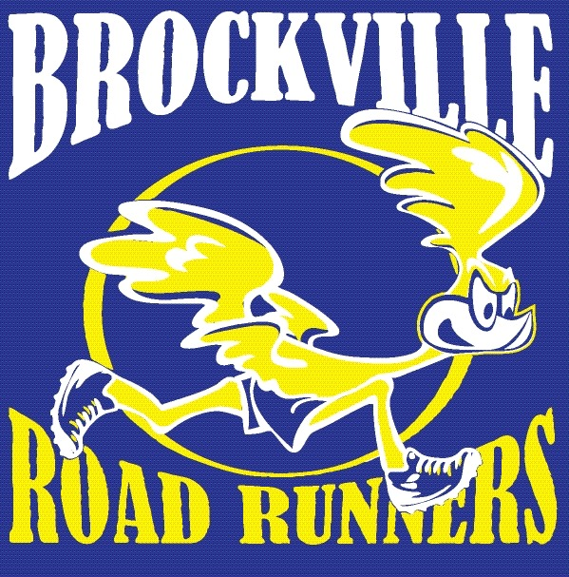
Brockville Road Runners Club

High School Student Bursary Form

(www.brockvilleroadrunners.com)

The Brockville Road Runners Club (BRCC) is an association that promotes active and healthy lifestyles, through participation in its organized activities. The club is not-for-profit, and prides itself with giving back to the community by supporting charities within Brockville and surrounding areas, supporting local high school bursaries and helping others in need.
CRITERIA: To be eligible for this bursary, valued at $100 to $200, the Grade 12 student(s) must be interested in pursuing or been accepted into a university or college level post-secondary program and has participated in and/or volunteered at events supported by the Brockville Road Runners Club such as the Freeze Your Buns Series, The Canada Day 5K, etc.
Please return or email this form to Mr. Cross at james.cross@ucdsb.on.ca no later than 11:59 p.m. on April 20 for consideration. He will send it to the BRCC on your behalf.

Student Information

Name:

Secondary School:

Email or Contact Information:

Post-Secondary Education Plans:

Please list how you are involved with the Brockville Road Runners Club:

_________________________________________ ___________________________________________
Signature of Applicant Signature of Principal (or designate)

